INDIAN SCHOOL AL WADI AL KABIR
Unit Test 1
SOCIOLOGY (Code:039)
Class: XII Time: 1 Hour
Date:28.05.2023 Max. Marks: 30
General Instructions:
1. The question paper is divided into three sections.
2. There are 16 questions in all. All questions are compulsory.
3. Section A includes question No. 1-10. These are objective type questions carrying 1mark each
4. Section B includes question No. 11-13. These are very short answer type questions carrying 2
marks each. Answer to each question should not exceed 80 words.
5. Section C includes question No.14-15. They are short answer type questions carrying 4
marks each. Answer to each question should not exceed 120 words.
6. Section D includes question No.16. They are long answer type questions carrying 6 marks
each. Answer to each question should not exceed 300 words. There’s an internal choice in Sections B, C&D. Please write answers on selected questions only.

 | SECTION A
1. | What factors help in controlling epidemics?  - Improvement in medical cure for certain diseases  - Programmes for mass vaccination  - Efforts to improve sanitation facilities  - All of the above | 1
2. | Assertion (A): The migration of men from the villages of the Himalyan regions can lead to an unsual proportion of women -headed families in the villages  Reason (R): The internal structure of a family is usually related to other structures of society, namely political, economic, cultural etc.  - Both A & R are true and R is the correct explanation of A  - Both A & R are true but R is not the correct explanation of A  - A is true but R is false  - A is false but R is true | 1
3. | Patterns of unequal access to social resources are commonly called ______  - social morbidity b. social pressure c. social inequality d. social justice | 1
4. | “Famines were also a major and recurring source of increased mortality.” Which of the following is not a cause of famines?  - Continuing poverty and malnutrition in an agro-climatic environment.  - Inadequate means of transport and communication  - Failure of entitlements  - Increasing birth rates | 1
5. | Which of the following make the Dominant Castes dominant?  - Small population  - Land rights  - Intermediate caste  - Decisive role in regional politics  - I and II  - I and III  - II, III and IV  - I and V | 1
6. | Historically the caste system classified people by their ______  - education and income b. occupation and status c. race and gender  - d. purity and pollution | 1
7. | Assertion (A): The Population Pyramid shows a bulge in the middle age groups, due to opportunity provided by the demographic structure.  Reason (R): This is due to high birth rate in the middle age groups.  - Both A & R are true and R is the correct explanation of A  - Both A & R are true but R is not the correct explanation of A  - A is true but R is false  - A is false but R is true | 1
8. | The ________ family is often seen as symptomatic of India.  - Nuclear  - Patriarchal  - Patrilineal  - extended | 1
9. | The person who is refused a job because of his/her caste may be told that he/she was less qualified than others and the selection was done purely on merit. This is an example of -  - discrimination  - social stratification  - egalitarianism  - stereotype | 1
10 | Person from a well-off family can afford expensive higher education. Someone with influential relatives and friends may- through access to good advice, recommendations or information- manage to get a well-paid job.  Which if the following is true in the given context?  - There are multiple forms of capital  - Different forms of capital cannot be converted into the other  - The forms of capital overlap  - I is false  - I and II are true  - I and III are true  - I, II and III are true | 1
 | SECTION B
11. | Why is the Malthusian theory of population criticised? | 2
12. | “In both English and Indian fictional writings, we often encounter an entire group of people classified as ‘lazy’ or ‘cunning’.” What are the problems with such a classification?  OR  What is the difference between assimilationist and integrationist policies? | 2
13. | What is untouchability? | 2
 | SECTION C
14. | Discuss India’s demographic achievement since independence.  OR  Why did Malthus believe that catastrophic events like famines and epidemics that cause mass deaths were inevitable? | 4
15. | One of the most significant yet paradoxical changes in the caste system in the contemporary period is that it has tended to become ‘invisible’ for the upper caste, urban middle and upper classes. For these groups, who have benefited the most from the developmental policies of the post-colonial era, caste has appeared to decline in significance precisely because it has done its job so well. Their caste status had been crucial in ensuring that these groups had the necessary economic and educational resources to take full advantage of the opportunities offered by rapid development. In particular, the upper cate elite were able to benefit from subsidized public education, especially professional educations in science, technology, medicine and management. At the same time, they were also able to take advantage of the expansion of state sector jobs in the early decade for Independence.  - What is caste? (2 marks)  - ‘For the so-called scheduled castes, tribes and the backward classes’, the opposite of what is mentioned in the passage as being true for upper caste and class has happened. For them caste has become all too visible. Explain why this is so. (2marks) | 4
 | SECTION D
16. | Question 1:  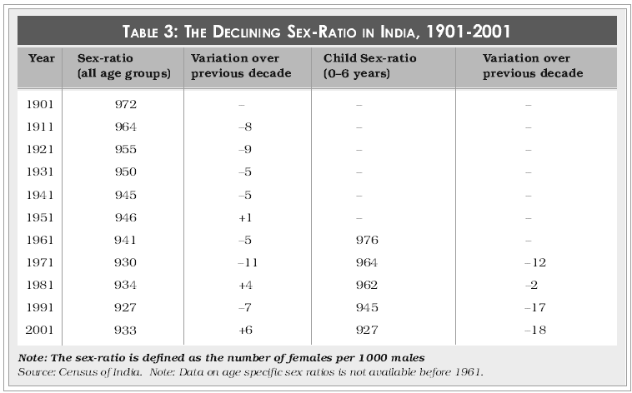  - Give reasons for declining sex-ratio  - In your opinion, what steps should be taken to deal with this bias against the girl-child?  OR  Question 2: What are the major concerns regarding the Adivasis today? | 6

